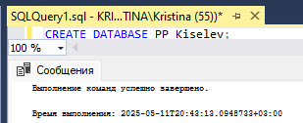

Рис 1. Создание БД

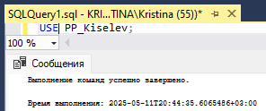

Рис 2. Использование БД

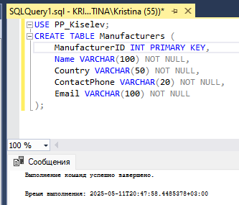

Рис 3. Создание таблицы (Скрипт)

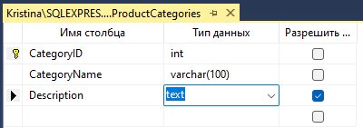

Рис 4. Создание таблицы (Вручную)

-- Создание базы данных PP_Kiselev

CREATE DATABASE PP_Kiselev;

USE PP_Kiselev;

-- Таблица Manufacturers (Производители)

CREATE TABLE Manufacturers (

ManufacturerID INT PRIMARY KEY,

Name VARCHAR(100) NOT NULL,

Country VARCHAR(50) NOT NULL,

ContactPhone VARCHAR(20) NOT NULL,

Email VARCHAR(100) NOT NULL

);

-- Таблица ProductCategories (Категории товаров)

CREATE TABLE ProductCategories (

CategoryID INT PRIMARY KEY,

CategoryName VARCHAR(100) NOT NULL,

Description TEXT

);

-- Таблица Products (Товары)

CREATE TABLE Products (

ProductID INT PRIMARY KEY,

ProductName VARCHAR(255) NOT NULL,

ManufacturerID INT NOT NULL,

CategoryID INT NOT NULL,

Price DECIMAL(10, 2) NOT NULL,

QuantityInStock INT NOT NULL,

FOREIGN KEY (ManufacturerID) REFERENCES Manufacturers(ManufacturerID),

FOREIGN KEY (CategoryID) REFERENCES ProductCategories(CategoryID)

);

-- Таблица Customers (Клиенты)

CREATE TABLE Customers (

CustomerID INT PRIMARY KEY,

FirstName VARCHAR(50) NOT NULL,

LastName VARCHAR(50) NOT NULL,

Phone VARCHAR(20) NOT NULL,

Email VARCHAR(100) NOT NULL,

Address VARCHAR(255) NOT NULL

);

-- Таблица Employees (Сотрудники)

CREATE TABLE Employees (

EmployeeID INT PRIMARY KEY,

FirstName VARCHAR(50) NOT NULL,

LastName VARCHAR(50) NOT NULL,

Position VARCHAR(100) NOT NULL,

HireDate DATE NOT NULL,

Phone VARCHAR(20) NOT NULL,

Email VARCHAR(100) NOT NULL

);

-- Таблица Orders (Заказы)

CREATE TABLE Orders (

OrderID INT PRIMARY KEY,

CustomerID INT NOT NULL,

EmployeeID INT NOT NULL,

OrderDate DATE NOT NULL,

TotalAmount DECIMAL(10, 2) NOT NULL,

Status VARCHAR(50) NOT NULL,

FOREIGN KEY (CustomerID) REFERENCES Customers(CustomerID),

FOREIGN KEY (EmployeeID) REFERENCES Employees(EmployeeID)

);

-- Таблица OrderDetails (Детали заказов)

CREATE TABLE OrderDetails (

OrderDetailID INT PRIMARY KEY,

OrderID INT NOT NULL,

ProductID INT NOT NULL,

Quantity INT NOT NULL,

UnitPrice DECIMAL(10, 2) NOT NULL,

FOREIGN KEY (OrderID) REFERENCES Orders(OrderID),

FOREIGN KEY (ProductID) REFERENCES Products(ProductID)

);

-- Таблица Suppliers (Поставщики)

CREATE TABLE Suppliers (

SupplierID INT PRIMARY KEY,

SupplierName VARCHAR(100) NOT NULL,

ContactName VARCHAR(100) NOT NULL,

Phone VARCHAR(20) NOT NULL,

Email VARCHAR(100) NOT NULL,

Address VARCHAR(255) NOT NULL

);

-- Таблица Supplies (Поставки)

CREATE TABLE Supplies (

SupplyID INT PRIMARY KEY,

SupplierID INT NOT NULL,

EmployeeID INT NOT NULL,

SupplyDate DATE NOT NULL,

TotalCost DECIMAL(10, 2) NOT NULL,

FOREIGN KEY (SupplierID) REFERENCES Suppliers(SupplierID),

FOREIGN KEY (EmployeeID) REFERENCES Employees(EmployeeID)

);

-- Таблица SupplyDetails (Детали поставок)

CREATE TABLE SupplyDetails (

SupplyDetailID INT PRIMARY KEY,

SupplyID INT NOT NULL,

ProductID INT NOT NULL,

Quantity INT NOT NULL,

UnitCost DECIMAL(10, 2) NOT NULL,

FOREIGN KEY (SupplyID) REFERENCES Supplies(SupplyID),

FOREIGN KEY (ProductID) REFERENCES Products(ProductID)

);

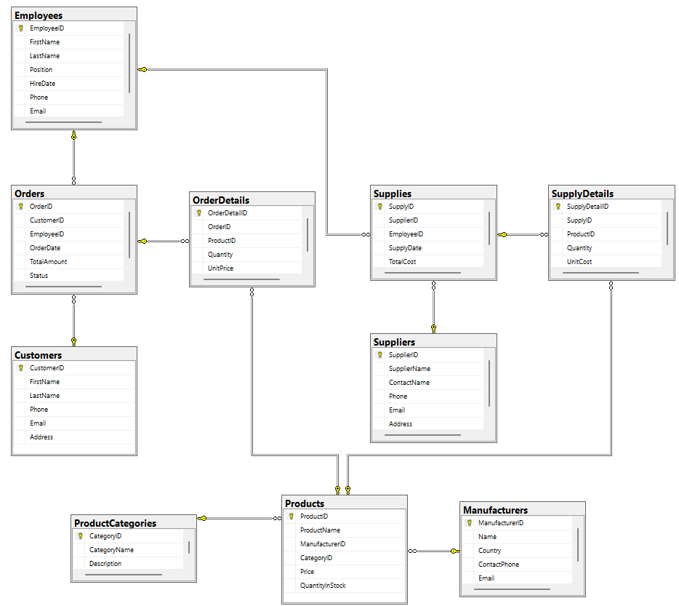

Рис 5. Диаграмма